**Title page-**

**CNC-based Bluetooth-operated Learning Aid for Children with Autism or Dyslexia.**

**Abstract-**

**The main objective of our team is to make a toy for kids who suffer from autism, spectrum disorder, or autism, a term used to**

**describe a group of neurodevelopmental conditions. Our team came by the resources, so according to specialists it has**

**been found that that, throughout the ages of digital transforming world when it is an e-learning platform and autism, a**

**proper output has not been observed as a result of it we actually could not predict whether the kid is getting addicted to**

**e-learning materials or he/she is learning it in real-time, at the same time to deal with the neurological problem we know that there**

**the brain isn't mature enough for a gripping power, fine and motor problem, which is found in maximum autistic kids, which is a**

**neurological problem. Our team aim is to create an interface between a mechanism or hardware with an e-learning**

**software or application.**

**Acknowledgement-**

We would like to express my deep and sincere gratitude to our research supervisor, Dr. E Vijayaragav sir , Professor and Head of , SRM Institute of science and Technology, Chennai for giving me the opportunity to do research and providing invaluable guidance throughout this research. His dynamism, vision, sincerity and motivation have deeply inspired me. He has taught me the methodology to carry out the research and to present the research works as clearly as possible. It was a great privilege and honour to work and study under his guidance. I am extremely grateful for what he has offered me. I would also like to thank him for his friendship, empathy, and great sense of humour.

Our team would further express our gratitude to Nilanjana Rambothu ma’am, Founder and Director of Sunshine Autism Care and consultant RCI holder in Special education (ASD) , for the time she has contributed to this project and for her constant encouragement. I express my special thanks to Mr Shantanu Sinha,marketing consultant with 24 years of experience in the Information Technology Industry with exposure in a wide range of technology, solution design and business consulting roles in TCS. for his genuine support throughout this research work.

Our team extended its gratitude to [Sampada Pachaury](https://www.linkedin.com/in/ACoAAAFvnSkB4kaB5wE9D-snUe5Wi9vhkcergZw) ma’am , [Krishna Vedula](https://www.linkedin.com/in/ACoAAACEbJcBGnZhwTKeoU1zOtHO4xEXdkV7bjM) sir and Aditya Bhatnagar sir for their diligent guidance and for their support during my research work with [Indo Universal Collaboration for Engineering Education ( IUCEE )](https://www.linkedin.com/company/indo-universal-collaboration-for-engineering-education/?lipi=urn%3Ali%3Apage%3Ad_flagship3_profile_view_base_recent_activity_details_shares%3BvhH%2BgA4MT7yiQFJSD8gohA%3D%3D).

Finally, our team thanks go to all the people who have supported me to complete the research work directly or indirectly.

**Table of contents-**

**Introduction**

1. Autism

[Autism and Developmental Disabilities Monitoring (ADDM) Network | CDC](https://www.cdc.gov/ncbddd/autism/addm.html#:~:text=What%20We've%20Learned,the%20United%20States%20during%202018.)

Autism is a term which is used to describe a particular group of people suffering from neurotypical conditions. Conditions which we can characterise by properties like being able to interact socially and communication problems. Autistic Spectrum Disorder is observed in people around the world, irrespective of culture, background, race and ethnicity.Repetitive interests of behaviour , the pattern of the restricted individual is observed in people with ASD, Autistic Spectrum Disorder.

During a study period of 2009-2017, children most of the age from 3-17 were seen diagnosed with disabilities, which includes cerebral palsy, blindness, hyperactivity disorder, autism.

1. How and why does it occur?

Conditions which are characterised by a contrast in social interaction and communication.Over the study it has been found that there are numerous causes. First of all it can be due to genetic mutations, having an immediate family member who is autistic. Fragile X syndrome and other genetic disorders being born to older parents, low birth rate. Metabolic imbalances. Exposure to heavy metals and environmental toxins. A history of viral infections , fatal exposure to the medications valproic or thalidomide.

1. Statistical data regarding autism population
2. Difficulties faced by these children in learning

**Children with autism might not reach the developmental milestone as their peers. Repetitive behaviour is observed in maximum such cases. They have difficulty sleeping and irregular food patterns.**

ASD children find the change in themselves in a stressful manner.They often prefer similar environment with a regular routine, due to their

Sensory aspect of their diagnosis, information processing and behavioural aspect too. Now these small changes like repetitive and restricted interests, heightened anxiety can be stressful.

1. Problem statement

Neurological problem is observed in maximum autistic kids. The fine motor and the gross motor problem is what they

suffer from.

Hence they find it difficult in writing , imagine how painful it is for an autistic kid to deal with such problem provide

the case that they want to learn and write.

1. Brief about the problem

The main objective of our team is to make a toy for kids who suffer from autism , spectrum disorder , or autism, term used to

describe a group of neurodevelopmental conditions. Our team came by the resources , so according to specialists it has

been found that that , throughout the ages of digital transforming world when it is an e learning platform and autism , a

proper output has not been observed as a result of it we actually could not predict whether the kid is getting addicted with

e learning materials or he/she is actually learning it, at the same time to deal with neurological problem we know that their

brain isn't mature enough for a gripping power , fine and motor problem , which is found in maximum autistic kids , which is a

neurological problem .

1. Aim

**Our team aim is to create an interface between a mechanism or a hardware with an e learning**

**software or application**

**Methodology**

**INTRODUCTION**

**our team is trying to create a loop between the play and physicial therapy , resulting in a therapy to kids who**

**have writing problem from their very childhood , kids who have difficulty to understand between 6 and 9 , b and d ,**

**the alphabetical order , a step from our team to make the basics strong and solve the neurological problem in kids.**

**As by the research we undergone and by the resources we can come to the point that autistic kid faces lots of**

**problems with their sensory nerves and their gross motor and fine motor and so on. We are working on a project with**

**an idea of making the kid to learn by making the kid to hold an artificial hand (robotic arm) or the mechanism as we**

**said as the hardware , which has the ability to track the pattern of the letter and to guide the kid to move their**

**hand in the right way to complete the pattern by interactive methods. Interactive methods will be the input given**

**from the phone or the device where the mentor or the guide will download the application or the software from.**

**And here We hope our idea would bring the changes in the kid positively.**

**A)Design and specifications**

1. Concept sketching
2. Design constraints.
3. A rough sketch of the model

**B)Control and Power System**

1. Analysis

* **Microcontroller used**

### **ATMEGA328P**

In todays world we have many controllers, then why ATMEGA328P?

ATMEGA328P is one of the popular because it is cost effective with exciting features in it.Even Arduino boards are developed on such a controller because of the features.

Features like , with variation on power saving modes it can be used on mobile embedded systems, it has the RISC architecture, as a result of it the program executes quickly, has a timer, the watchdog timer to reset anytime under error on the system with just a human interface and so on.RISC is nothing but a reduced instruction set computer which is a type of architecture which used hugly optimised set of instruction than what found in other architectures.

ATMEGA is quite the same as any other microcontrollers in the market.And yes we all know there should be a set of instructions in the form of programs provided by us at instant, without the program nothing is executing the way it should be.As already discussed , there should be a program present in the ATMEGA328 flash memory.This whole execution is done by the controller after the code is dump and provides appropriate response.

Lets see how we should extract the the process into the following steps,

* First step is we need to list out all the functions that the controller should execute. Functions in programming language can be run at IDE, now here we can use the Arduino IDE too to be discussed later. After the code we need to compile to look for errors.
* The IDE converts the compiled program to HEX file. The HEX file constitutes the machine code that is executed or written in the controller flash memory.
* Choose the programming device (usually SPI programmer made for AVR controllers) which establishes communication between PC and ATMEGA328P. You can also program ATMEGA328P using the ARDUINO UNO board.
* After the execution all we need to do is , to disconnect the programmer, and connect with the appropriate peripherals for the controller and run the system.

**FEATURES**

1. **The CPU used is an 8-bit AVR with a speed of 1MBPS for 1MHz .**
2. **There are a total 28 pins present.**
3. **Operating voltage ranges from +1.8 V TO +5.5V.**
4. **Number of programmable I/O lines is 23. There are three types of communication interface, Master/Slave SPI Serial Interface(17,18,19 PINS), Can be used for programming this controller.**
5. **Programmable Serial USART. Pins can be used for programming this controller. Two-wire Serial Interface pins are used to connect peripheral devices like memory devices, sensors and servos.**
6. **It has ADC Module Of 6 channels, 10-bit resolution ADC. Timer module of two 8-bit counters with Separate Prescaler and compare mode. One 16-bit counter with Separate Prescaler,compare mode and capture mode.**
7. **There are a total of 1 analog comparator with 6 PWM channels.**
8. **External Oscillator with 0-4MHz in 1.8V to 5.5V, 0-10MHz in 2.7V to 5.5V, 0-20MHz in 4.5V to 5.5V and an internal oscillator with 8MHz Calibrated Internal Oscillator.**
9. **Program Memory Type is of flash memory with 32 kbytes. RAM is 2kbytes Internal SRAM with an EEPROM of 1k bytes.**
10. **Programmable Watchdog Timer with Separate On-chipOscillator with program lock.**
11. **6 major power save modules, Idle, ADC Noise Reduction, Power-save, Power-down, Standby and Extended Standby.**
12. **Operating Temperature is -40°C to +105°C.**

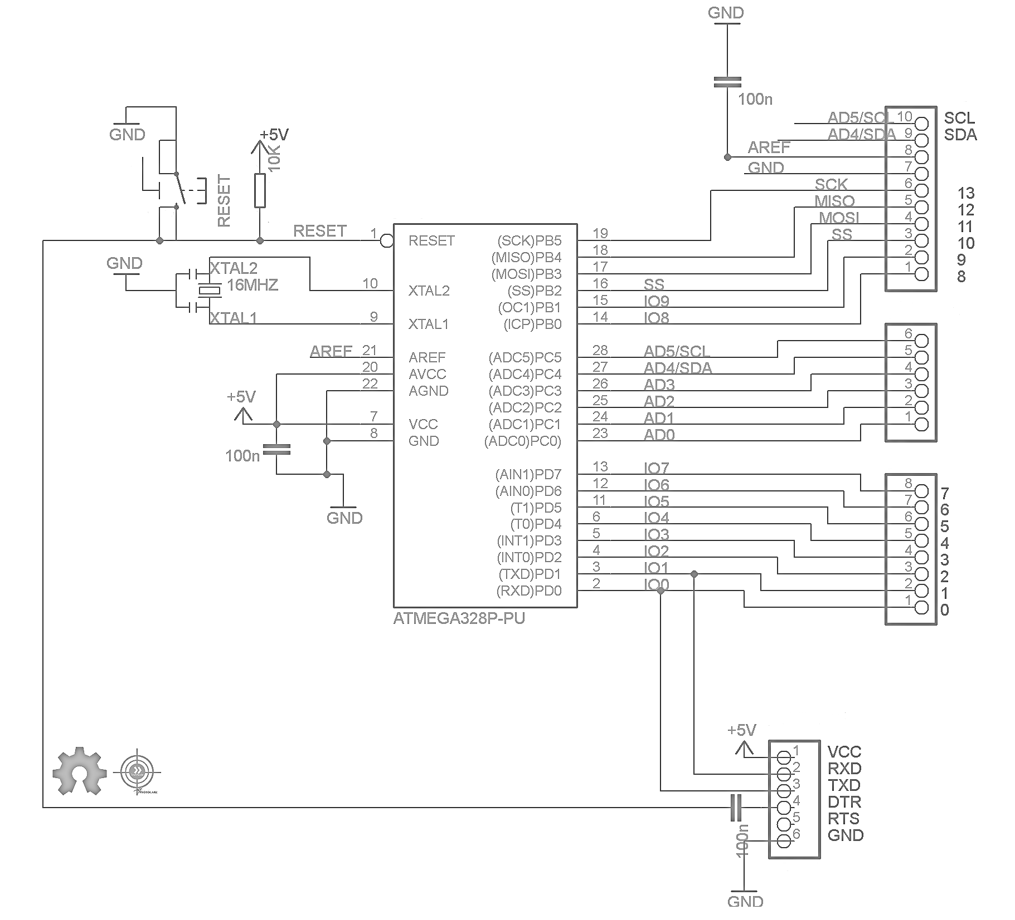

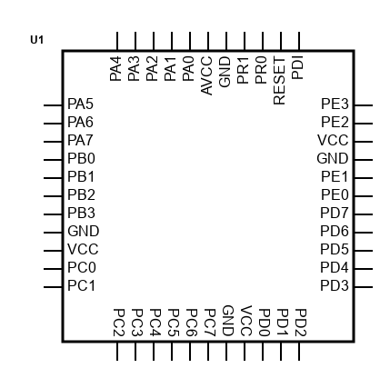

* **Motor Driver used**

**CNC SHEILD V3**

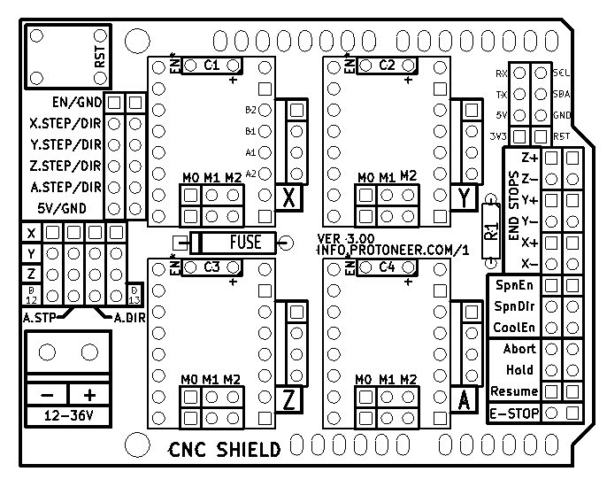

**The shield used CNC Shield v3, is made for particularly arduino based controllers which allows us to build such machines which is used to engrave, like a mini CNC, A 3D printer and so on.It just needs to be fit on the top of the arduino with no external wiring required. As we can see there are a total of 4 slots for stepper motor drivers in the shield. The shield before running with the stepper motor needs to install the GRBL firmware to enable the controller to work in parallely with the shield.**

**The shield supports a input voltage of 12V to 36V.If we put an input of more than 36V it will burn the motor drivers. Motor drivers like A4988, DRV8825. A4988 is used in the project.Features:-**

* **As it is known that it is particularly made for building 3D printers or we can just simply say any project where we need to control a stepper motor.**
* **Arduino compatible shield which allows the user to connect 4 stepper motor with the latest arduino shield version 3.10**
* **The shield is GRBL compatible , GRBL is an open source firmware which is programmed into the arduino and enables the GCODE to run through it , we will see a bit about the GCODE later on.**
* **The shield does support PWM signal as a result of which the spindle is way easier with 4 axis , X,Y,Z,A.**
* **It is a compact shield with coolant ability, even it supports a removable A4988 stepper driver which is very well compatible with the shield.**
* **The shield runs on 12-36V DC.**

**Stepper drivers**

**A4988 or DRV8825 compatible stepping driver**

**The stepping driver, A4988 has a built in translator for being easily operated , a complete microstepping motor driver. The drivers can be used to control bipolar motors in full, half, quarter, eigth and sixteenth step modes.**

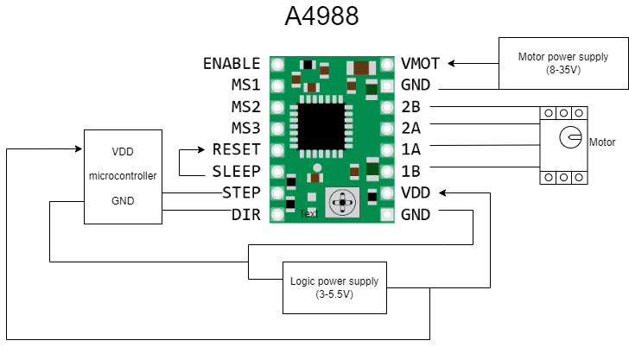

* **Motors used**

**Stepper motor.**

**A stepper motor can be defined as a DC motor which does not rotate in a continuous motion. It rotates by taking one step at a time, with the energy iput given to it. Thereby a stepper motor converts electrical energy into mechanical shaft rotation.**

**The project deals with the principle of CNC machines and in such cases nothing is better than the stepper motor. Stepper motors are a vital part in the case of moving the x,y,z axis. Stepper motors are built unique to hold the position and at a fixed interval. Thereby it is often seen that the stepper motor is used in the field of robotics and printers particularly.Stepper motors do come in a variety. Some preferable stepper motors are the NEMA series , NEMA is nothing but the measurement standard provided by the National Electrical Manufacturers Association.NEMA 14, NEMA 17, NEMA 23, and NEMA 24 are few sizes.Larger the frame does not conclude increase in torque.**

**Servo motor.**

**Servo motor can be defined as a motor with a specific part, suitable for a closed loop control system. Servo motors are used in robotics, CNC machining applications and so on. There is the control signal which is the input, it can be analog or digital, representing the final position for the shaft. A encoder serves the role of a sensor with speed and position.**

**The project deals with the principle of Computer Numeric Control (CNC) machine and in such cases nothing is better than the stepper motor to convert instructions into actions. Here action is depicted as the up and down of the pen for writing and moving to the next consecutive letter.**

* **Wireless module**

**Bluetooth HC-05,**

**Bluetooth HC-05 can be defined as a serial communication to communicate with the world of electronics. Connecting to devices with short range to exchange files. Just the way files are going to get exchanged in the project with a frequency band of 2,4 GHz. HC-05 has a transfer rate of 1Mbps within a range of 10meters. Input power voltage is 4-6V with a baud rate of 9600, 19200, 38400, 57600, as selected by the user.**

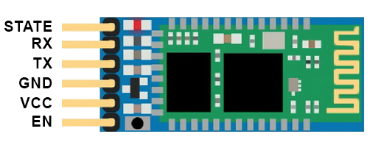

**EN(Enable)- Pin which is used to set the data mode at command mode**

**VCC - Pin which is connected to +5V power supply.**

**Ground - Pin which is connected to the coround of the system.**

**Tx (Transmitter) - Pin which is used to transmits the received data**

**Rx (Receiver) - Pin which is used for broadcasting data.**

**State -Pin which is used to check if the bluetooth module is working properly or not.**

1. Design constraints
2. Overview

**C)Software**

1. Introduction
2. Layers
   1. SYSTEM ARCHITECTURE DIAGRAM

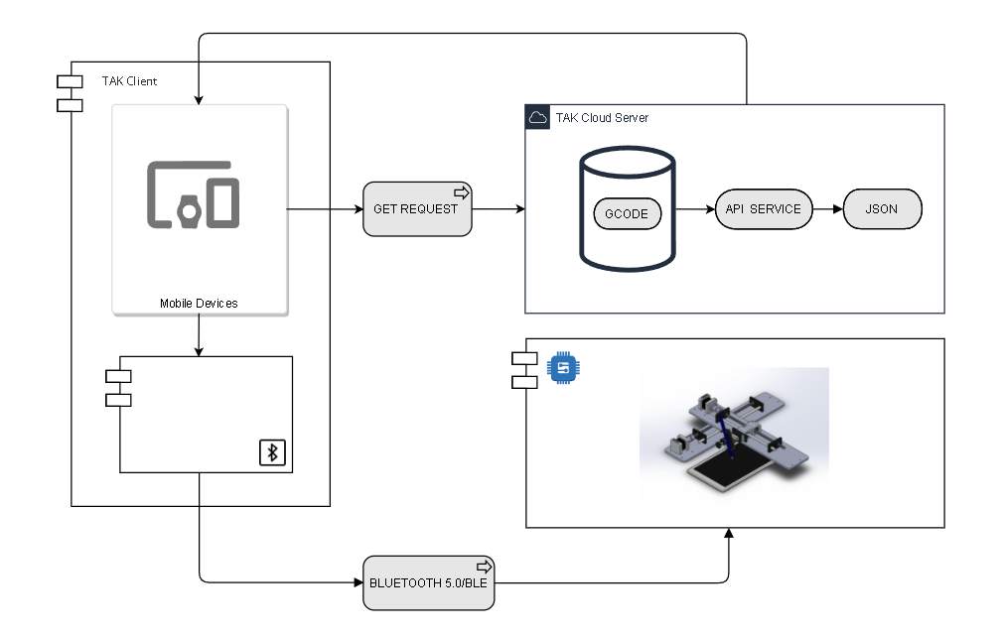

B. SEQUENCE DIAGRAM

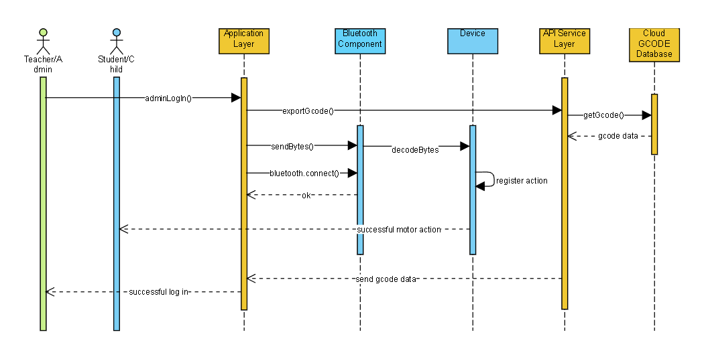

1. Algorithm
2. simulation
3. Design constraints
4. Database
5. Overview

**Implementation**

1. Procedure
2. Specification
3. Aim & design

**Evaluation**

1. Result
2. Evaluation
3. Features
4. How it can improve the learning capabilities
5. User case studies
6. Limitations

**Future Work**

1. Compact
2. Portable

Conclusions

our team has come up with the conclusion that living in the 21st century where kids are born and brought up

in the age of technologies and the digital world we must fix and deal with such challenging problems. Often people

do have e-learning software but again, we fail to realize how it really affects the kids and also helps the kid to grow

and evolve. Growth is a very essential part of life, and growing with just a digital interface is not what our duty is. Our

duty is to make it efficient and worth the time and money they have spent on their development. We depict or

define our machine or an artificial hand as a scope to neural science in future. We know that not only autistic kids

but many people do face neurological problems where if they want to write they cannot do so but our machine the

robotic hand will automatically create an impact on the disabled person. The combination of the concepts of

Mechatronic and neuroscience will create a huge impact and make learning very easy for every person suffering

from neurological problems. We create the future a place for great effortless learning and writing.

Reflections

Living in the 21st century where kids are born and brought up in the age of technologies and the digital world we must fix and deal with such challenging problems. Often people do have e-learning software but again, we fail to realise how it really affects the kids and also helps the kid to grow and evolve. Growth is a very essential part of life, and growing with just a digital interface is not what our duty is. Our duty is to make it efficient and worth the time and money they have spent on their development.Through out the surveys and webinar it has been found that the machine or an artificial hand as a scope to neural science in future. It is know that not only autistic kids but many people do face neurological problems where if they want to write they cannot do so but our machine thea robotic hand will automatically create an impact on the disabled person. The combination of the concepts of Mechatronic and neuroscience will create a huge impact and make learning very easy for every person suffering

from neurological problems. Not only that, it will change the vision of a CNC handwriting machine which is only

made for purpose to print , but here many dots are connected together towards an environmental step in

curing the neurological problem of an autistic kid , who has a writing problem. A highly recommended survey was made throughout the survey with a positive response for this TLM(Teaching Learning Material). Many questions were answered positively from the audience regarding the final product.

Reference

[Trends over time in the number of children with autism according to the... | Download Scientific Diagram (researchgate.net)](https://www.researchgate.net/figure/Trends-over-time-in-the-number-of-children-with-autism-according-to-the-IDEA-and-in-the_fig7_291186663)

[Europe PMC](https://europepmc.org/article/med/12876158)

[Prevalence of Autism Increases by 10%, to 1 in 54 Children | Southwest Autism Research & Resource Center (SARRC) (autismcenter.org)](https://autismcenter.org/prevalence-autism-increases-10-1-54-children)

[Neurotypical Peers are Less Willing to Interact with Those with Autism based on Thin Slice Judgments | Scientific Reports (nature.com)](https://www.nature.com/articles/srep40700)

[Impact of mainstream classroom setting on attention of children with autism spectrum disorder: an eye-tracking study | SpringerLink](https://link.springer.com/article/10.1007/s10209-020-00749-0)

[Autism and Developmental Disabilities Monitoring (ADDM) Network | CDC](https://www.cdc.gov/ncbddd/autism/addm.html#:~:text=What%20We've%20Learned,the%20United%20States%20during%202018.)

[ATMega328P Microcontroller Pinout, Pin Configuration, Features & Datasheet (components101.com)](https://components101.com/microcontrollers/atmega328p-pinout-features-datasheet)

[PROJECT | Scheme-it | Free Online Schematic and Diagramming Tool | DigiKey Electronics](https://www.digikey.in/schemeit/project/project-4053c3c6ebc149cd9ae47c63cc9c2e9f/)

[CNC Shield V3 - Engraving Machine 3D Printer Expansion Board buy online at Low Price in India - ElectronicsComp.com](https://www.electronicscomp.com/cnc-shield-v3-3d-printer-a4988-expansion-board)

[Arduino UNO + Arduino CNC Shield V3.0+A4988 Installation Guide « osoyoo.com](https://osoyoo.com/2017/04/07/arduino-uno-cnc-shield-v3-0-a4988/)

<https://www.techopedia.com>